BCOM 311
KISII 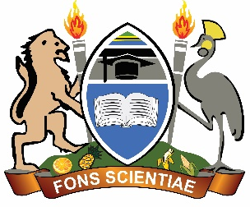UNIVERSITY
UNIVERSITY EXAMINATIONS

SPECIAL/SUPPLEMENTARY EXAMINATIONS
THIRD YEAR EXAMINATION FOR THE AWARD OF THE DEGREE IN BACHELOR OF HUMAN RESOURCE MANAGEMENT
SECOND SEMESTER, 2024/2025
(AUGUST, 2025)

BCOM 331: MONEY AND BANKING

STREAM: Y3 S2 TIME: 2 HOURS

DAY: WEDNESDAY, 12.00-02.00 PM DATE: 13/08/2025

INSTRUCTIONS
- Do not write anything on this question paper.
- Answer Question ONE [Compulsory] and any other THREE Questions.

QUESTION ONE :[25 MARKS ]
- Explain the role of the Central Bank and how it may influence the performance of the a country’s economy [10 marks]
- Explain the major monetary standards in the Kenyan economy
[10 marks]
- Describe the historical development /evolution of money.[5 marks ]
QUESTION TWO :[15 MARKS ]
- What monetary policies can a government adopt to reduce inflation
[7marks]
- Explain any four functions of money. [8 marks]

QUESTION THREE :[15 MARKS ]
- Explain reasons for liquidity preference for money. [4 marks]
- Discuss the major economic defects of money [5 marks]
- What are the main causes of the huge budget deficit being experienced in most sub-Saharan African countries including Kenya? [6 marks]

QUESTION FOUR :[15 MARKS ]
- Discuss the creation of commercial bank money in any modern financial system. [7 marks]
- Explain the role of commercial banks in your country. [8 marks]
QUESTION FIVE :[15 MARKS ]
- Discuss the Keynesian theory of demand for money and the prepositions that hold it true. [8 marks ]
- Discuss any 7 characteristics of money. [7 marks ]

