GEOG 202
KSU/DAQA/FORM F
KISII 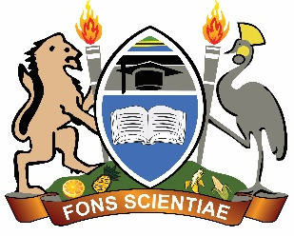UNIVERSITY
UNIVERSITY EXAMINATIONS
SPECIAL /SUPPLEMENTARY EXAMINATIONS

SECOND YEAR EXAMINATION FOR THE AWARD OF THE DEGREE
OF THE BACHELORS OF ARTS AND EDUCATION ARTS
SECOND SEMESTER 2024/2025
(JANUARY – APRIL, 2025)

GEOG 202: ENVIRONMENT AND DEVELOPMENT IN AFRICA

STREAM: Y2 S2 TIME: 2 HOURS

DAY: MONDAY, 12.00 – 2.00 P M DATE: 11/08/2025

INSTRUCTIONS:
- Do not write anything on this question paper.
Answer Question One (Compulsory) and Any Other TWO Questions

QUESTION ONE
- Explain the following concepts: (6 Marks)
- Environmental management actions
- Environmental justice
- Environmental risk
- Discuss various methods of conserving biological diversity in Africa (14Marks)
- Explain the relationship between environmental issues and water security in Africa (10 Marks)
QUESTION TWO
- Discuss why pollution continues to be an increasing problem for the conservation of biological diversity (10 Marks)
- Write an essay on the strategies for environmental conservation (10 Marks)

QUESTION FOUR
- Discuss the major problems confronting the environmental activists in achieving their goals of maintaining quality environments (10 Marks)
- Explain the influence of climate change on the performance of the environmental. (10 Marks)
QUESTION THREE
Give a reasoned assessment of the environmental issues in public health management in Africa. (20 Marks)
QUESTION FIVE
Describe the environment as an asset in relation to an economic system (20 Marks)

