GEOG 203
KSU/DAQA/FORM F
KISII UNIVERSITY
UNIVERSITY EXAMINATIONS
SPECIAL /SUPPLEMENTARY EXAMINATIONS

SECOND YEAR EXAMINATION FOR THE AWARD OF THE DEGREE
OF THE BACHELORS OF ARTS AND EDUCATION ARTS
SECOND SEMESTER 2024/2025
(JANUARY – APRIL, 2025)

GEOG 203: PRACTICAL GEOGRAPHY AND FIELD WORK

STREAM: Y2 S2 TIME: 2 HOURS

DAY: MONDAY, 12.00 – 2.00 P M DATE: 11/08/2025

INSTRUCTIONS:
- Do not write anything on this question paper.
Answer Question One (Compulsory) and Any Other TWO Questions

QUESTION ONE
(a) Describe the aims of statistical diagrams and maps in studying geographical features (8 Marks)
(b) Explain TWO major types of quantitative point data (6 Marks)
c The following information shows the traffic flows in different routes:

Route | Vehicles
A | 1000
B | 750
C | 450
D | 255
E | 850
A+C | 1450
D+E | 1125

Required:
(i) Taking a scale, 1mm to represent 100 vehicles, construct a flow-line map (10 Marks)
(ii) Discuss the advantages and disadvantages of the above type of map (6 Marks)
QUESTION TWO
- Describe the process of surveying (10 Marks)
- Using suitable Geographical examples differentiate between Pie charts and proportional circles (10 Marks)
QUESTION THREE
(a) Define the following terms(distribute the 8 marks for each of the sub areas of the question) (8 Marks)
(i) Circuit
(ii) Accessibility
(iii) Connectivity
(iv) Surveying
(b) Discuss the merits of network analysis according to K.J. Kanskey, 1963 (6 Marks)
(c) Outline key reasons for transforming network into graphs. (6 Marks)
QUESTION FOUR
By use of illustrations, explain the main types of map projections. (20 Marks)

QUESTION FIVE
The table below gives figures for annual rainfall in millimeters for the year 1987-1988 for each of rain gauge stations marked A-Y.
Station Rainfall (mm) Station Rainfall (mm)
A 839.3 N 653.6
B 898.7 O 776.7
C 896.9 P 1137.5
D 711.2 Q 949.3
E 758.5 R 655.3
F 1182.8 S 812.3
G 1607.4 T 1110.2
H 616.1 U 675.9
I 842.8 V 691.0
J 1027.2 W 750.3
K 1047.5 X 933.9
L 1172.3 Y 787.9
M 1292.1
(a) Choosing a suitable Isoline interval, draw a neat Isohyet Map to show the years distribution of rainfall over the area (10 Marks)
(b) Comment on the effectiveness of this method as a means of mapping rainfall distribution (5 Marks)
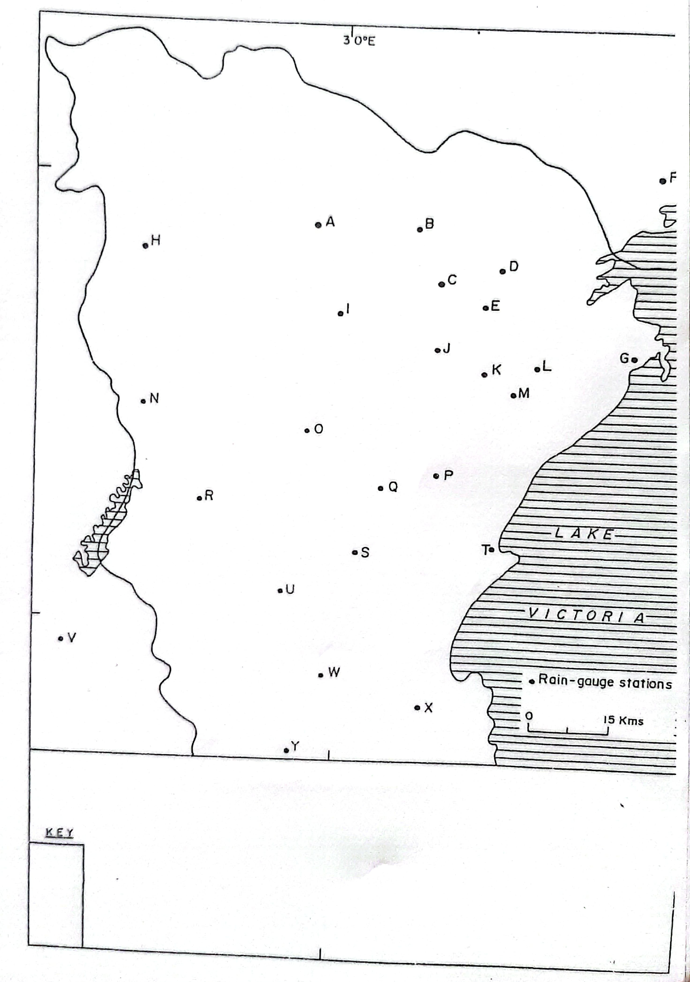
(c) Describe the pattern of rainfall distribution over the area. (5 Marks)

