GEOG 222
KSU/DAQA/FORM F
KISII 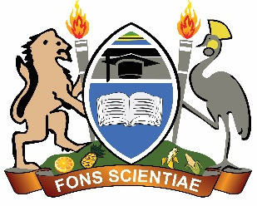UNIVERSITY
UNIVERSITY EXAMINATIONS
SPECIAL /SUPPLEMENTARY EXAMINATIONS

SECOND YEAR EXAMINATION FOR THE AWARD OF THE DEGREE
OF THE BACHELORS OF ARTS AND EDUCATION ARTS
SECOND SEMESTER 2024/2025
(AUGUST, 2025)

GEOG 222: EARTH’S SURFACE PROCESSES

STREAM: Y2 S2 TIME: 2 HOURS

DAY: WEDNESDAY, 3.00 – 5.00 P M DATE: 13/08/2025

INSTRUCTIONS:
- Do not write anything on this question paper.
Answer Question One (Compulsory) and Any Other TWO Questions
QUESTION ONE
a) Define geomorphology and explain its significance in understanding earth surface processes (10 Marks)
b) Discuss the theory of Plate Tectonics and its role in shaping the Earth’s surface. (12 Marks)
c) Explain the effects of earthquakes on landform development. (8 Marks)
QUESTION TWO
a) Describe the different types of volcanoes and their impacts on the environment. (10 Marks)
b) Explain the process of faulting and how it contributes to landform development. (10 Marks)

QUESTION THREE
a) Discuss the various agents of erosion and their role in landscape modification. (10 Marks)
b) Explain the major types of weathering and how they influence landform evolution. (10 Marks)
QUESTION FOUR
a) Define mass wasting and describe the different types of mass movements. (12 Marks)
b) Explain how climatic factors influence geomorphological processes. (8 Marks)
QUESTION FIVE
Explain the process of wave erosion and its resultant landforms. (20 marks)

