BFBT 314
KISII 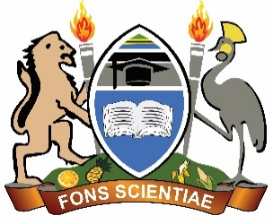UNIVERSITY
UNIVERSITY EXAMINATIONS

SPECIAL/SUPPLEMENTARY EXAMINATIONS
THIRD YEAR EXAMINATION FOR THE AWARD OF THE
DEGREE OF BACHELOR OF SCIENCE IN BIOLOGICAL SCIENCE/FORENSIC BIOLOGY OF PURE AND APPLIED SCIENCES
FIRST SEMESTER, 2024/2025
(AUGUST, 2025)

BFBT 314: HISTOPATHOLOGY

STREAM: Y3S1 TIME: 2 HOURS

DAY: THURSDAY, 12:00-2:00 PM DATE: 07/08/2025
INSTRUCTIONS
- Do not write anything on this question paper.
- Answer ALL questions in section A and any TWO questions in section B.

SECTION A Answer all Questions – 40 marks
- Briefly explain any three methods of diagnosing blood disorders. (6 marks)
- Briefly explain any three major types of anaemia and their pathophysiology. (6 marks)
- Outline five differences between leukaemia and myeloproliferative disorders. (5 marks)
- Briefly explain the process of haemopoiesis. (6 marks)
- (a) Define immunopathology. (1 mark)
(b) Briefly describe any three autoimmune diseases. (6 marks)
- Briefly describe the pathophysiology of cardiovascular diseases, focusing on one condition. (6 marks)
- Briefly explain any 4 major causes of lymphadenopathy. (4 marks)

SECTION B (Answer ANY 2 questions) – 30 Marks
- Discuss any five methods for diagnosing and monitoring pulmonary diseases. (15 marks)
- Assume you have been employed in a pathology lab. You have been tasked with preparing blood smears to study the morphology of platelets. Explain the process, including equipment and stains used. (15 marks)
- Discuss any five applications of histopathology in diagnosing cardiovascular diseases. (15 marks)

